#### IN – PLANT TRAINING REPORT

**At**

**ITC Pvt Ltd, Agri-Business Division, Guntur**

# Submitted to in partial Fulfilment of the Requirements

#### For the Award of the degree

#### IN

#### Food Technology

#### 2022-2023

(01-02-2023 to 31-05-2023)

#### 

#### IN-PLANT TRAINING

#### 

#### FDPO-454

#### ACHARYA N. G. RANGA AGRICULTURAL UNIVERSITY

#### Dr. N. T. R COLLEGE OF FOOD SCIENCE AND TECNOLOGY

**BAPATLA, Dist., 522101**

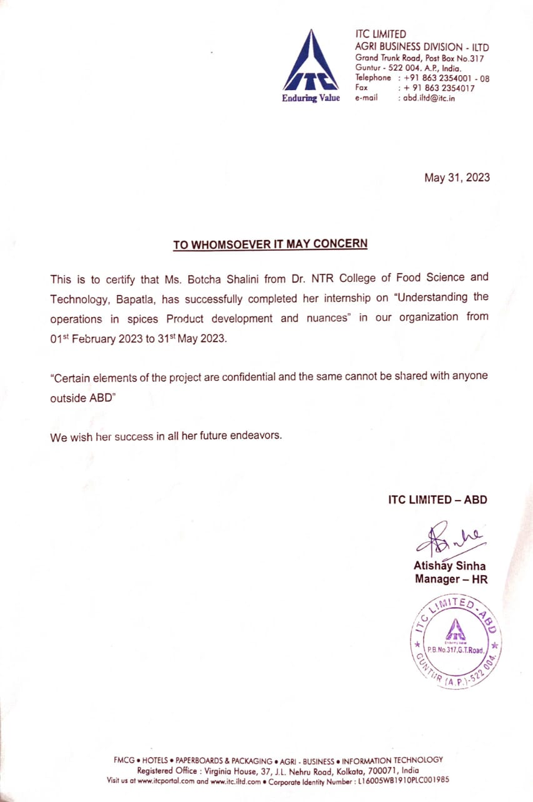

#### DECLARATION

We declare that the report submitted to the Dr NTR College of Food Science and Technology, Bapatla, Acharya N. G. Ranga Agricultural University, Guntur under the course title IN-PLANT TRAINING (FDPO 454) for the award of the Degree of Bachelor of Technology in Food Technology is the Bonafede In-Plant Training work Experience undergone by us at **ITC, Pvt, Ltd., Agri-Business Division, Guntur** from 01-02-2023 to 31-05-2023 under the guidance of **Mr. K. Usha Kiran , Manager**, **Product Development**. We further declare that it is our original work as a part of our academic course.

**Advisor: Submitted by**

Dr. Vimala BeeraB. Shalini (BF19-048)

Asst. Professor

**ACKNOWLEDGEMENT**

We take this opportunity with immense happiness to express our profound gratitude and unfathomable regards to our Placement In-charge **Dr. Ch.V.V Satyanarayana**, Professor &Head, Department of Food Process Engineering for his support at each step of work. We also thank our guide **Dr. Vimala Beera,** Assistant Professor, Department of Food Safety and Quality Assurance, Dr. NTR College of Food Science &Technology for her exemplary guidance, monitoring, and unvarying encouragement throughout the course of this report.

We also take this opportunity to express a deep sense of gratefulness to **Mr. K. Usha Kiran , Manager, Mrs. Rashmi Chetula** for their amiable and affable support, priceless information, and supervision, which helped us in completing this project through various stages.

It is our proud privilege to express our gratitude to **Dr. Y. Radha**, Associate Dean, Dr.NTR College of Food Science and Technology, Bapatla, for constant supervision and support during our In-Plant Training.

Our sincere & heartfelt thanks to **Dr. Vinodha,** Assistant Professor**, Dr. Ch. Someshwara Rao**, Assistant Professor, **Mrs. K. Sowjanya,** Assistant Professor**, Dr. S. Blessy Sagar** Assistant Professor, **Mrs. R. Preethi Sagar**, Teaching Associate**, Dr. Y. Srinivas**, Teaching Associate at Dr NTR College of Food Science and Technology, Bapatla for their words of encouragement that further intoxicated us to work harder.

We are obliged to colleagues of **ITC Pvt Ltd., Agri- Business Division, Guntur** for the precious information provided by them in their respective fields. We are thankful for their co-operation during the period of our assignment.

**Place:**

**Date:**

B. Shalini

(BF-19-048)

**IN-PLANT TRAINING SCHEDULE**

|  |  |  |
| --- | --- | --- |
| S. No | Name of the company | Period |
| 1 | ITC Pvt, Ltd., Agri-Business Division, Guntur | 01-02-2023 to 31-05-2023 |

**CONTENTS**

|  |  |  |
| --- | --- | --- |
| **S.NO** | **TITLE** | **PAGE NO.** |
| 1 | EXECUTIVE SUMMARY | 6 |
| 2 | INTRODUCTION ABOUT COMPANY | 7 |
| 3 | PRODUCT DEVELOPMENT LABORATORY | 9 |
| 4 | SPICES | 10 |
| 5 | R&D, QUALITY AND PRODUCT DEVELOPMENT IN ITC | 12 |
| 6 | VARIETIES OF CHILLI, TURMERIC, CORIANDER,CUMIN | 14 |
| 7 | CUSTOMER DEALING: | 19 |
| 8 | PROCESS FLOW CHARTS IN PRODUCT DEVELOPMENT LAB:(FOR IPM AND NIPM PRODUCTS) | 20 |
| 9 | CONCLUSION | 22 |

**EXECUTIVE SUMMARY**

ITC Agri Business is one of India’s leading marketers of Agri-produce in world markets. Building enduring relationships with farmers for over a century, it has empowered farmers and helped in transforming rural lives and landscapes.

In ITC-ABD the products which are mainly operated are: Product Basket: Chilli, Turmeric, Ginger, Seed Spices (Cumin, Coriander, Fennel, Fenugreek & Celery), blended spices.

My area of work in these past four months is in the Research and Development department.

Under Research and Development department I have worked in New Product Development.

Product Development is the process of developing the new products based on the customer Requirement. This product development is mainly done in the spices Division. In Product Development lab two types of products will be prepared They are: 1. STRAIGHT SPICES 2. BLENDED SPICES

STRAIGHT SPICES include chillies, turmeric, cumin, coriander, fenugreek etc by using the varieties in chillies, turmeric etc. the blends are prepared.

Whereas blended spices include the products like Garam masala, curry powder s, fish masala etc. Blends are prepared based on the customers’ Requirements. The customer may give a Target sample to match or they may ask the sample with some specifications. The specification will be having the physical, chemical, Microbiological Parameters. The chilli blends will be prepared based on the capsaicin (pungency in SHU units) level and ASTA (colour) level. In turmeric, blends will be prepared based on the curcumin level

Similarily for cumin and coriander the blends will be prepared based on the volatile oil ranges. If customer asks for the sterilized product, then the sterilization is done to the product. Types of sterilizations are 1. Steam Sterilization 2.ETO (Ethylene Oxide) Sterilization. The customer dealings will be done as IPM and NIPM customers. I have done 120 blends using the chilli and turmeric, cumin and coriander varieties.

I have mainly involved in making the Blends, Creating the specifications as per the customer requirement, Creating the lab codes for sending the samples for analysis, Packing and sending the samples for sterilization, Checking and Entering the results after analysis. I suggest to get Improvement in blending, build a solid product strategy, Always strive for Quality.

**Objective:**

1. To achieve integrated development of all kinds of spices grown in the state.
2. To give impetus spices grown in india to the international markets.
3. To promote spices grown in Guntur in the national and the international markets.
4. To facilitate transfer of latest technological know-how to the spice growers.
5. To empower the traders with the professional business abilities and skills.
6. To arrange / conduct business promotion activities such as, exhibitions, trade fairs / meals, seminars, symposiums, workshops, demonstrations, etc., related to spices and their products.
7. To coordinate and collaborate with the Government, Government Undertakings, financial institutions, research organizations, SAUs, UHS, UAHS, NGOs, National trade organizations, state marketing institutions like KHF, District HOPCOMS and the like, for furthering the cause of the spices research, development, extension and promotion in the State.
8. To implement the schemes related to spices development in the state, in a coordinated manner.
9. To encourage farmers commodities groups, associations and producers companies.
10. To document and publish important events and professional information’s related to spices in the form of periodicals, newsletters and other versions.
11. To organize, encourage and support exposure visits and study tours for farmers, entrepreneurs and officers.
12. To encourage and support the processors in the field of spice processing.

**ITC**

**ABOUT THE COMPANY ITC LIMITED**

ITC LIMITED is an Indian multinational conglomerate company headquartered in Kolkata, West Bengal. Established in 1910 as the Imperial Tobacco Company of India Limited, the company was renamed as the India Tobacco Company Limited in 1970 and later to I.T.C. Limited in 1974. The company now stands renamed to ITC Limited, where "ITC" today is no longer an acronym or an initialized form.

ITC also became the first Indian company to foray into consumer research during this time. During the 1960s, technology was given more focus on setting up cigarette machinery and filter-rod manufacturing facilities aimed at achieving self-sufficiency in cigarette-making. ITC is the country's leading FMCG marketer, the clear market leader in the Indian Paperboard and Packaging industry, a globally acknowledged pioneer in farmer empowerment through its wide reaching Agri Business, a pre-eminent hotel chain in India that is a trailblazer in 'Responsible Luxury'. ITC's wholly-owned subsidiary, ITC Infotech, is a specialized global digital solutions provider. Over the last decade, ITC's new Consumer Goods Businesses have established a vibrant portfolio of 25 world-class Indian brands that create and retain value in India.

# ITC's world class FMCG brands including Aashirvaad, Sun feast, Yippee! Bingo! B Natural, ITC Master Chef, Fabelle, Sunbean, Fiama, Engage, Vivel, Savlon, Classmate, Paperkraft, Mangaldeep, Aim and others have garnered encouraging consumer franchise within a short span of time.

**ITC AGRI BUSINESS DIVISION**

ITC Agri Business is one of India’s leading marketers of Agri-produce in world markets. Building enduring relationships with farmers for over a century, it has empowered farmers and helped in transforming rural lives and landscapes.

ITC, leveraged our century long relationship with farmer community to provide food safe solutions to the world. Their backward integration programme, connects with more than 10,000 farmers across 170+ villages to produce 13,000+ MT of Spices.

In ITC-ABD the products which are mainly operated are: Product Basket: Chilli, Turmeric, Ginger, Seed Spices (Cumin, Coriander, Fennel, Fenugreek & Celery), blended spices.

Major products in ITC:

• Spice

• Fruit pulp

• Tomato puree

• Wheat products

• Seasonings

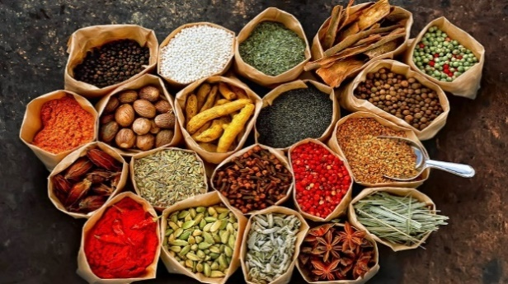

Fig-1: Different Spices

Spices are generally classified into:

1. Straight Spices

2. Blended Spices

3. Seasonings

Straight spices: Straight spice means a single spice in whole, crushed or powdered form from any part of plant used to flavour, garnish etc. Example -Chilly, clove, nutmeg, turmeric, etc.

Blended spices: Blended spices are the mix of more than one spice. Blended Spices doesn’t give the taste of the product to which it is going to be added. Example: Curry Powder

Seasonings: Seasoning is a blend of salt, sugar, additives and spices which serves a purpose. Seasoning also gives the taste of the product to which it is going to be added.

**PRODUCT DEVELOPMENT LABORATORY**

• Prototyping laboratory – Blends, seasoning

• Pilot facility – Small scale, sieving, grinding.

• Ingredient laboratory – Raw materials needed

• Sensory station

• Application studio – cooking

**STRAIGHT SPICES ITC**

• Chilli (Lal Mirch)

• Turmeric (Haldi)

• Coriander (Dhania)

• Cumin

**BASED ON**

• SHU (defining the attributes of heat)

• ASTA (defining the attributes of colour)

**BLENDED SPICES ITC**

Around the world, there is a growing demand for authentic spice blends to enable quick and consistent replication of dishes, and traditional Indian spice blends are among the most popular.

**OFFERINGS:**

• North Indian Blends

• South Indian Blends

• Mughlai Blends

• International Blends

**ITC SPICE ADVANTAGE**

India’s largest IPM chilli growers with customized region-specific backward integration programmes for farmer partners in Andhra Pradesh, Telangana and Karnataka. As a leading manufacturer of chilli powder and supplier of other chilli products for the global market, They comply to EU, US, Australian and Japanese food safety norms in terms of pesticide residues, aflatoxin (as low as 5 ppb), foreign matter and heavy metal content.

OFFERINGS:

• Whole (with stem & de-stemmed), Crushed / Minced Ground

**SPICES**

ITC Spices was established as an independent business in 2004. Located in Guntur, Andhra Pradesh – “the chilli capital of the world” – ITC Spices has emerged as a leader in backward integrated food safe spices. ITC spices engages extensively with 10,000 farmers partners across 210 villages with a crop area of offer customers the finest food safe spices which comply with the most rigorous food safety norms. Through its century-long partnership with farming communities, ITC spices is uniquely positioned to implement large-scale interventions at the farm level which focus intensely on building sustainability – In terms of agricultural production, livelihoods and environmental resources. As a result, ITC spices are today a preferred and trusted supplier to major food customers worldwide.

Because they tend to have strong flavors and are used in small qualities, spices tend to add few calories to food, even though many spices, especially those made from seeds, contains high proteins of fat, protein, and carbohydrate by weigh. However, when used in large quantity, spices can also contribute a substantial amount of minerals and micronutrients, including iron, magnesium, calcium, and many others, to the diet. For example, a teaspoon of paprika contains about 1133 IU of vitamin A, which is over 20% 0f the recommended daily allowance specified by the US FDA. Most herbs and spices have substantial antioxidant activity, owing primarily to phenolic compounds, especially flavonoids, which influence nutrition through many pathways, including affecting the absorption of other nutrients. One study found cumin and fresh ginger to be highest in antioxidant activity. This antioxidant can also act as natural preservatives, preventing or slowing the spoilage of food, leading to a higher nutritional content in stored food.

**1.5 DEFINITION OF SPICE**

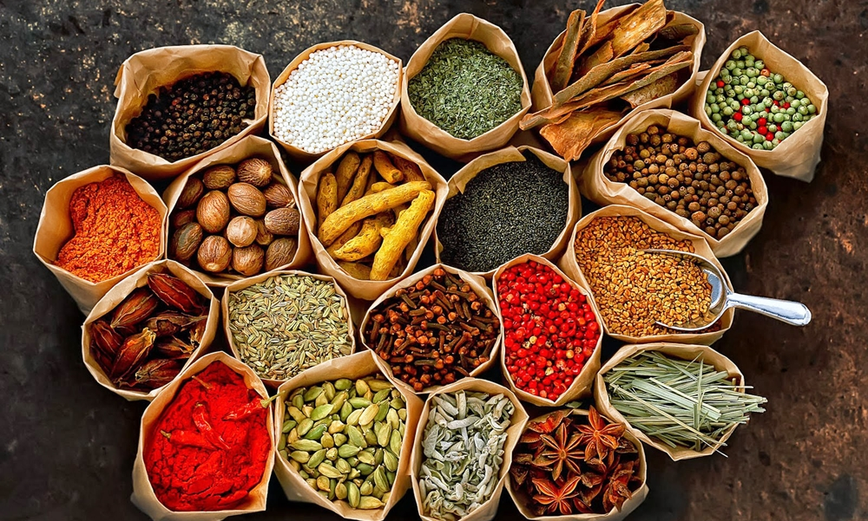

Fig-2 Spices

The Geneva-based International Standards Organization (ISO) defines spices and condiments as the vegetable products or mixtures free from extraneous matter, used for flavouring, seasoning and imparting aroma in foods.

Webster describes spices as any of various aromatic vegetable productions as pepper, cinnamon, nutmeg, mace, ginger, cloves, etc. used in cookery to season and to flavour sauces, pickles etc., a vegetable condiment or relish, usually in the form of powder also, as condiments collectively.

The famous Spice author Rosengarten describes a spice as a product which enriches or alters the quality of a thing, for example altering the taste of a food to give it zest or pungency; a piquant or lasting flavoring; or relish. The term ‘spice’ is thus used to cover the use of spices, herbs and certain aromatic vegetables to impart odour and flavour to foods.

**GENERAL CLASSIFICATION OF SPICES**

Spices are generally classified into:

1. Straight Spices

2. Blended Spices

3. Seasonings

Straight spices: Straight spice means a single spice in whole, crushed or powdered form from any part of plant used to flavour, garnish etc. Example: -Chilly, clove, nutmeg, turmeric, etc.

Blended spices: Blended spices are the mix of more than one spice. Blended Spices doesn’t give the taste of the product to which it is going to be added. Example: Curry Powder

Seasonings: Seasoning is a blend of salt, sugar, additives and spices which serves a purpose. Seasoning also gives the taste of the product to which it is going to be added. Raw materials required: 1. Top note (flavour)

2. Functional Ingredients (salt, sugar, additives)

3. Body (Spices)

4. Filler (silica, oil).

Example: The best example of seasoning is Maggie masala, Tikka masala

**R&D, Quality and Product Development in ITC**

Recognizing that cutting-edge R&D can foster breakthrough innovation and create powerful sources of sustainable competitive advantage, ITC continues to invest in this area, leveraging its world-class infrastructure, benchmarked processes, state-of-the-art technology and a business-focused R&D strategy.

With a team of over 350 world-class scientists, the state-of-the-art ITC Life Sciences & Technology Centre in Bengaluru is engaged in developing unique sources of competitive advantage and building future readiness by harnessing contemporary advances in science and technology, applying them in product development and leveraging cross-business synergies

ITC’s R&D capabilities are utilised to develop future products in nutrition, health and well-being. In Agri sciences, its efforts are aimed at developing new crop varieties with higher yields, better quality and other traits relevant to the Company’s businesses. In a short span of time, ITC has applied for over 350 patents in India itself.

**New Product Innovation and Development**

CPGs need to keep on innovating and develop new products as the consumer requirements change. CPGs also struggle to keep the wallet share, mindshare, shelf space, and need an accelerated product innovation and development. We work with global CPG companies’ to effectively use technology frameworks to accelerate new product development, optimize R&D budgets, improve quality, and comply with regulations.

We achieve this by plugging into the strategic pull and mapping projects with business initiatives to strengthen the organizational commitment in delivering new products and solutions. Through program management that drives the integration of key function and ensures our customers deliver quality products on time; going beyond primary and secondary linkages to cover tertiary linkages and dependencies to avoid delays in the launch of new products; and through a learn-improve-learn execution cycle that incorporates incremental learnings into product development. Depending on the customer’s preferences, we deploy either structured tools for ‘lean product development’ or short ‘post-implementation reviews’ for new products.

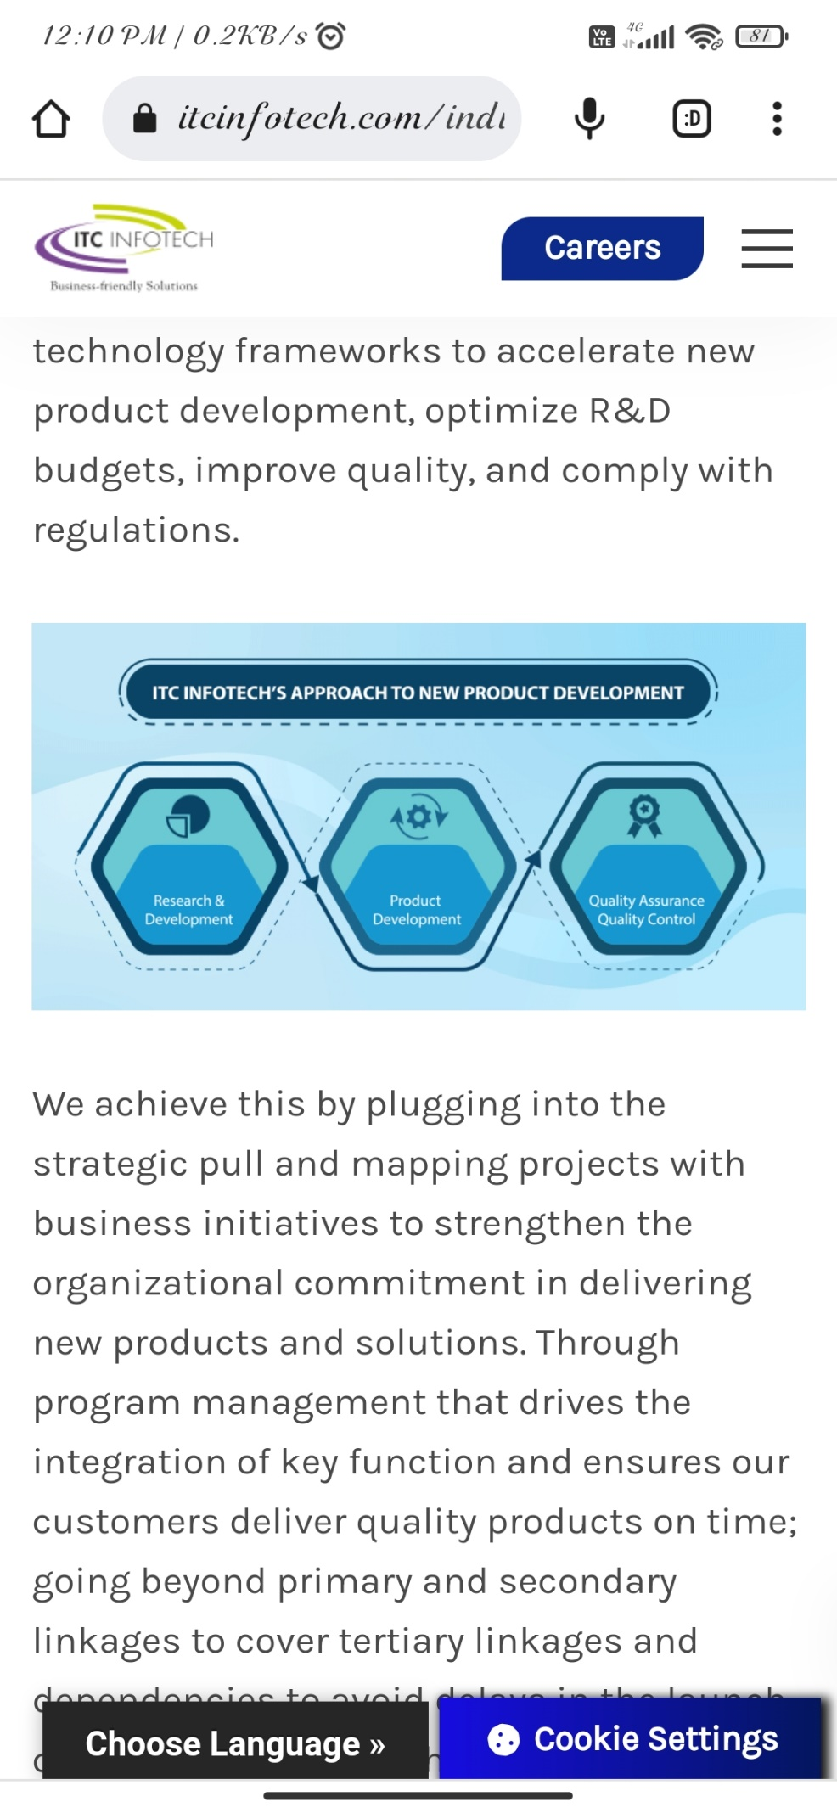

FIG-3: ITC Approach to new product development

**VARIETIES OF CHILLI:**

**TABLE-1: VARIETIES OF CHILLI**

|  |  |  |
| --- | --- | --- |
| **Chilli Varieties** | | |
| **Variety** | **SHU** | **ASTA** |
| **Mundu** | 15000-25000 | Min 30 |
| **341** | 35000-45000 | Min 100 |
| **DD** | 45000-55000 | 100 |
| **S.Byd** | 40000-50000 | 110 |
| **Teja** | 70000-90000 | Min 50 |
| **334** | 15000-25000 | Min 50 |
| **K.Byd** | 5000-15000 | 120-180 |
| **273** | 15000-22000 | Min 80 |
| **4884** | 70000-100000 | Min 50 |
| **5531** | 40000-50000 | 110 |
| **ARM** | 70000-90000 | Min 50 |
| **IND** | Upto 48000 | 60 |
| **WH** | 5000-6000 | 60-70 |
| **CPT** | 3000-5000 | 90 |
| **2043** | 10000-15000 | Min 120 |
| **Tepa** | 35000-45000 | Min 40 |

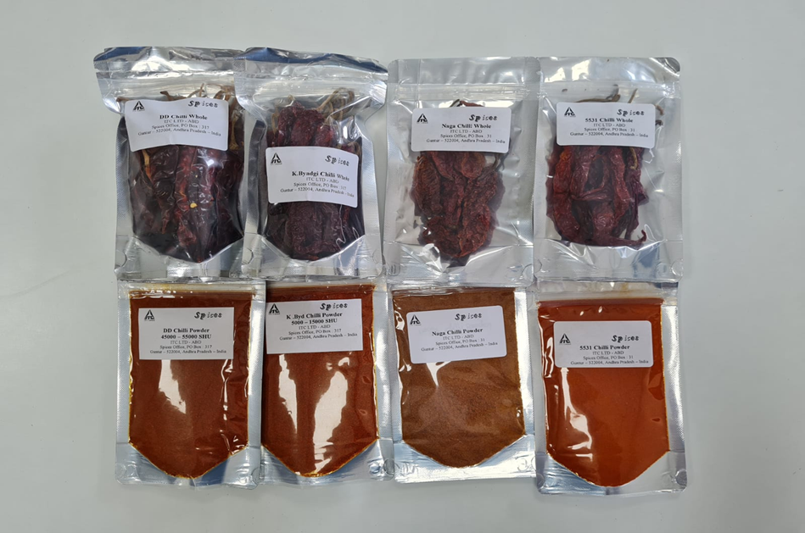

Fig:4. varieties of chilli whole and powders

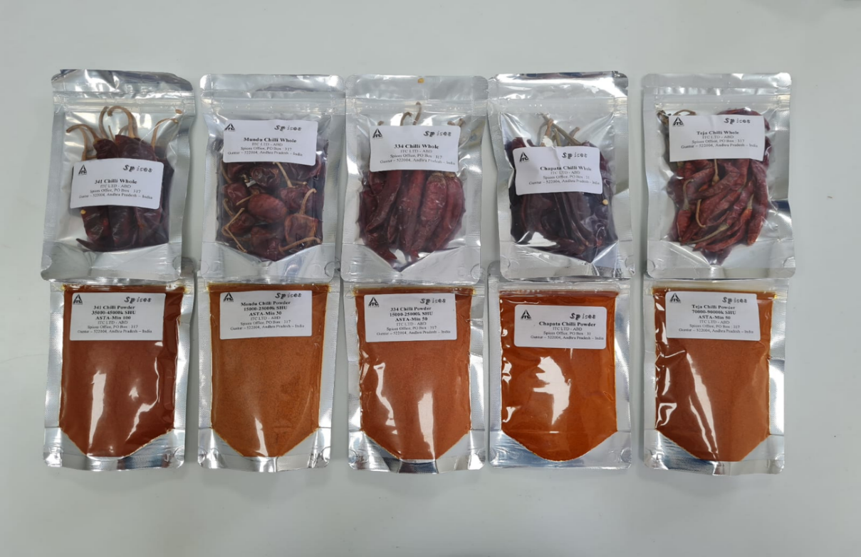

Fig-5: varieties of chilli whole and powders

**VARIETIES IN TURMERIC:**

**TABLE-2: CURCUMIN CONTENT FOR DIFFERENT VARIETIES**

|  |  |
| --- | --- |
| **Turmeric** | |
| **Variety** | **Curcumin(%)** |
| Assam | 1 |
| Orrisa | 1 to 2 |
| Erode | 1 to 2 |
| Cuddapah | 1 to 2 |
| Desi Cuddapah | 1 to 2 |
| Mysore Hybrid | 2 to 3 |
| Nizamabad | 2 to 3 |
| Basmath | 2.5 to 3.5 |
| Selam | 2.5 to 3.5 |
| Warangal | 4 to 5 |
| Waigav | 4 to 5 |
| Madugula | 4 to 5 |
| Rajapuri | 5 to 6 |
| Lackdong | 5 to 6 |
| Allepy | 5 to 6 |

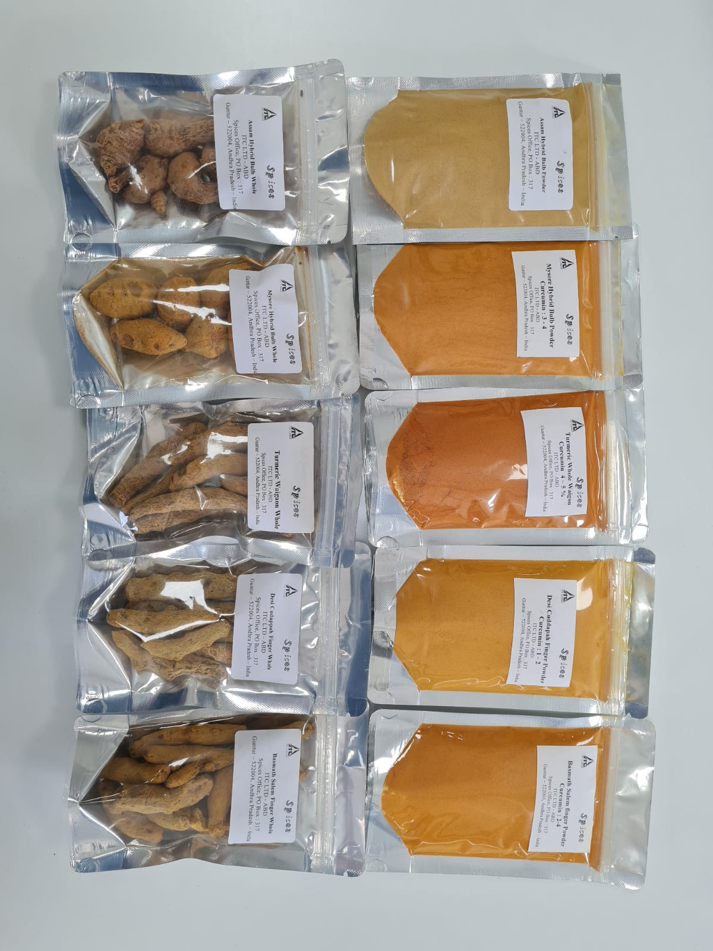

**FIG:6- VARIETIES IN TURMERIC**

* **TYPES OF CUMIN:**
* Cumin whole single sortex
* Cumin whole Double sortex
* Tailcut Cumin whole
* Cumin whole Uncleaned

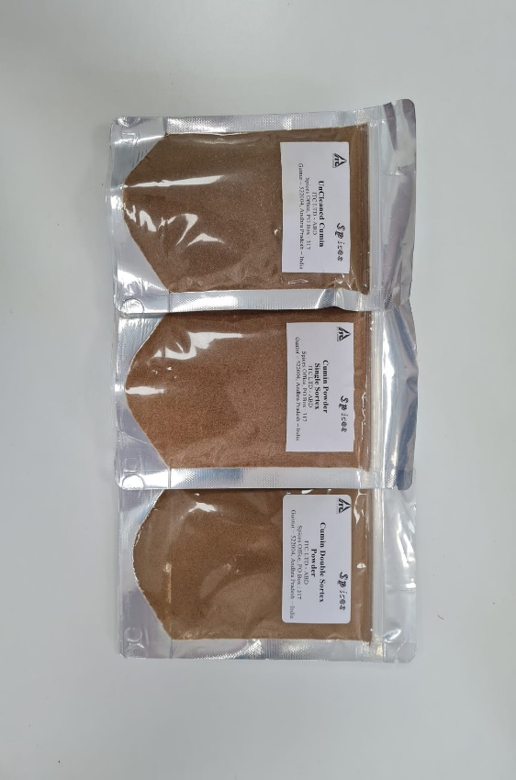

Fig:7- varieties of cumin powders

**TYPES OF CORIANDER:**

* Brown Badami whole
* Bulgarian whole
* Single parrot coriander
* Double parrot coriander
* Scooter whole
* Eagel whole

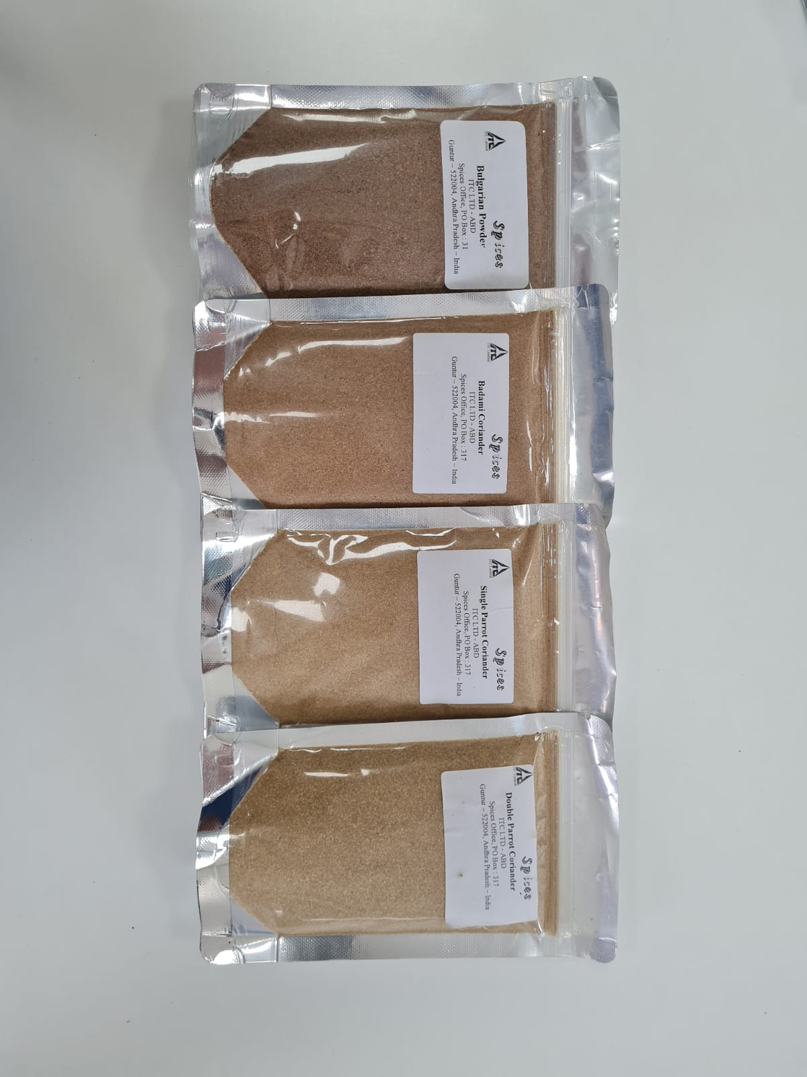

FIG:8- TYPES OF CORIANDER

* Product Development is the process of developing the new products based on the customer Requirement.
* This product development is mainly done in the spices Division.
* In Product Development lab two types of products will be prepared
* They are: 1. STRAIGHT SPICES

2.BLENDED SPICES

* STRAIGHT SPICES include chillies, turmeric, cumin, coriander, fenugreek etc by using the varieties in chillies, turmeric etc. the blends are prepared.
* Whereas blended spices include the products like Garam masala, curry powder s, fish masala etc.

**Process of preparing different blends:**

* Blends are prepared based on the customers’ Requirements
* The customer may give a Target sample to match or they may ask the sample with some specifications.
* The specification will be having the physical, chemical, Microbiological Parameters.
* The chilli blends will be prepared based on the capsaicin (pungency in SHU units) level and ASTA (colour) level
* In turmeric, blends will be prepared based on the curcumin level
* Similarily for cumin and coriander the blends will be prepared based on the volatile oil ranges.
* If customer asks for the sterilized product, then the sterilization is done to the product.
* Types of sterilizations are 1. Steam Sterilization

2.ETO (Ethylene Oxide) Sterilization

**CUSTOMER DEALING:**

* The customer dealings will be done through IPM and NIPM
* IPM-Integrated Pesticide Management
* NIPM- Non-Integrated Pesticide Management
* IPM is for the international export
* NIPM is for the local markets.

**Process in product development lab:(For IPM and NIPM Products):**

* **For Sterilized product:**

Flow chart-1: Process for sterilized product

**For Unsterilized product:**

Flow chart-2: Process for unsterilized product

**CUSTOMERS:**

**IPM RUNS NIPM RUNS**

Deep foods FSK

Sleaford Reliance

NATCO AVA

CAPEHERBS SURYAA MASALA

HALDIRAMS

ABW

**Conclusion:**

* New product development is an important way for business to stay ahead of the competition and continue to appeal to the changing needs of existing customers.
* Making the Blends.
* Creating the specifications as per the customer requirement.
* Creating the lab codes for sending the samples for analysis.
* Packing and sending the samples for sterilization.
* Checking and entering the results after analysis
* In addition, new product development can open up new marketing channels and help to increase market share.
* However, there is need to have the right strategies in place to provide unifying and successful direction.